Task No 01
Question No 01:
Write a program that creates two child processes and uses Pipes to pass a message in a chain: Parent → Child1 → Child2. Show that program runs correctly by displaying relevant outputs in terminal windows during program execution.
Solution:

#include<iostream>
#include<unistd.h>
#include<fcntl.h>
#include<sys/wait.h>
#include<stdlib.h>
#include<string.h>
using namespace std;
int main(){
int pipe1[2],pipe2[2];
const char mesg[]="Message From paren to child 1";
char buffer1[100],buffer2[100];
if (pipe(pipe1)==-1||pipe(pipe2)==-1)
{
cout<<"Pipe Cant Create !!"<<endl;
return 1;
}
pid_t child1=fork();
if (child1 < 0) {
perror("Fork failed");
exit(1);
}
if (child1==0)
{
pid_t child2=fork();
if (child2<0)
{
cout<<"Fork Failed"<<endl;
exit(1);
}
if (child2==0)
{
close(pipe1[0]);
close(pipe1[1]);
close(pipe2[1]);
read(pipe2[0],buffer2,sizeof(buffer2));
cout<<"Child 2 Recived : "<<buffer2<<endl;
close(pipe2[0]);
}else{
close(pipe1[1]);
cout<<"Child 1 Recived Message: ";
read(pipe1[0],buffer1,sizeof(buffer1));
cout<<buffer1<<endl;
strcat(buffer1," Forward by Child 1");
// child 1 send to child 2
close(pipe2[0]);
write(pipe2[1],buffer1,strlen(buffer1)+1);
close(pipe2[1]);
close(pipe1[0]);
}
}
else{
close(pipe1[0]);
write(pipe1[1],mesg,strlen(mesg)+1);
cout<<"Parent Send Message To Child 1: "<<mesg<<endl;
close(pipe1[1]);
}
return 0;
}

Output:
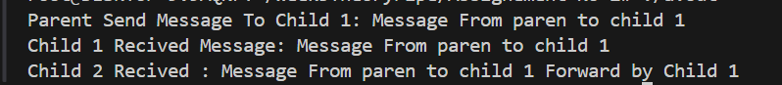
Task No 02
Question 02:
Create a simple client-server application having full duplex communication between them by using Anonymous pipes. The client (child) sends a command to server (parent), and server responds accordingly. For example, client sends a command to open a file file1.txt to server, server opens the file, reads first 10 lines of file, and then sends these lines to client. Client saves the received data to another file, file2.txt.

Solution:
#include <iostream>
#include <unistd.h>
#include <fcntl.h>
#include <sys/wait.h>
#include <stdlib.h>
#include <string.h>
using namespace std;

int main() {
int pipe1[2], pipe2[2];
char buffer[1024];

if (pipe(pipe1) == -1 || pipe(pipe2) == -1) {
cerr << "Pipe creation failed!" << endl;
return 1;
}

pid_t pid = fork();
if (pid < 0) {
cerr << "Fork failed!" << endl;
return 1;
}

if (pid == 0) {
close(pipe1[0]);
close(pipe2[1]);

const char fileCommand[] = "file.txt";
write(pipe1[1], fileCommand, strlen(fileCommand));
cout << "Client: Request sent to server -> " << fileCommand << endl;

int n = read(pipe2[0], buffer, sizeof(buffer));
if (n > 0) {
buffer[n] = '\0';
cout << "Client: Received data from server:\n" << buffer << endl;
int fd = open("output.txt", O_WRONLY | O_CREAT | O_TRUNC, 0644);
if (fd < 0) {
cerr << "Error opening output.txt" << endl;
} else {
write(fd, buffer, n);
close(fd);
cout << "Client: Data written to output.txt" << endl;
}
}
close(pipe1[1]);
close(pipe2[0]);
} else {
close(pipe1[1]);
close(pipe2[0]);

int n = read(pipe1[0], buffer, sizeof(buffer));
if (n > 0) {
buffer[n] = '\0';
cout << "Server: Received request -> " << buffer << endl;
int fd = open(buffer, O_RDONLY);
if (fd < 0) {
cerr << "Server: Cannot open file " << buffer << endl;
const char msg[] = "File not found!";
write(pipe2[1], msg, strlen(msg));
} else {

char line[256];
string content;
int lines = 0;
while (lines < 10 && read(fd, line, sizeof(line) - 1) > 0) {
content += line;
lines++;
}
write(pipe2[1], content.c_str(), content.size());
close(fd);
cout << "Server: Sent first 10 lines to client" << endl;
}
}

close(pipe1[0]);
close(pipe2[1]);
wait(NULL);
}

return 0;
}

Data File.txt
The sun set behind the mountains quietly.
A cat slept peacefully on the window sill.
Raindrops danced on the old tin roof.
The wind whispered secrets through the trees.
She opened the book and smiled at the story.
Coffee aroma filled the small kitchen.
The clock ticked loudly in the empty room.
Stars sparkled in the midnight sky.
He laughed at the unexpected joke.
Footsteps echoed along the empty corridor.
Output:
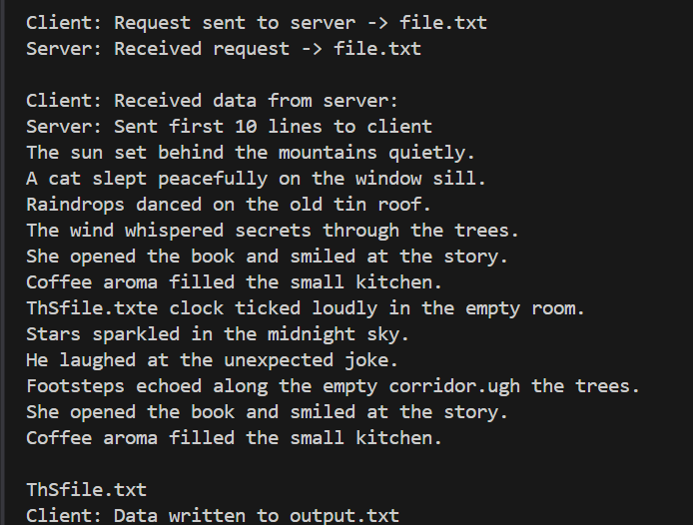

Task No 03
Question 03 :
Build a simple chat application for full duplex communication using two Named pipes (one for each direction of communication). Provide screen shots of message communication for at least 4 message exchanges.
Solution:
#include <iostream>
#include <unistd.h>
#include <fcntl.h>
#include <sys/stat.h>
#include <string.h>
#include <stdlib.h>
using namespace std;

int main() {
const char *fifo1 = "fifo1";
const char *fifo2 = "fifo2";

mkfifo(fifo1, 0666);
mkfifo(fifo2, 0666);

char message[200];
char reply[200];

int role;
cout << "Enter role (1 for User A, 2 for User B): ";
cin >> role;
cin.ignore();

cout << "Chat started! Type 'exit' to quit.\n";

while (true) {
if (role == 1) {
// ---------- User A ----------
cout << "You: ";
cin.getline(message, sizeof(message));

int fdw = open(fifo1, O_WRONLY);
write(fdw, message, strlen(message) + 1);
close(fdw);

if (strcmp(message, "exit") == 0)
break;

int fdr = open(fifo2, O_RDONLY);
read(fdr, reply, sizeof(reply));
close(fdr);

if (strcmp(reply, "exit") == 0) {
cout << "User B left the chat.\n";
break;
}

cout << "User B: " << reply << endl;
}
else {
// ---------- User B ----------
int fdr = open(fifo1, O_RDONLY);
read(fdr, message, sizeof(message));
close(fdr);

if (strcmp(message, "exit") == 0) {
cout << "User A left the chat.\n";
break;
}

cout << "User A: " << message << endl;

cout << "You: ";
cin.getline(reply, sizeof(reply));

int fdw = open(fifo2, O_WRONLY);
write(fdw, reply, strlen(reply) + 1);
close(fdw);

if (strcmp(reply, "exit") == 0)
break;
}
}

cout << "Chat ended.\n";
return 0;
}

Output:
Terminal 1:
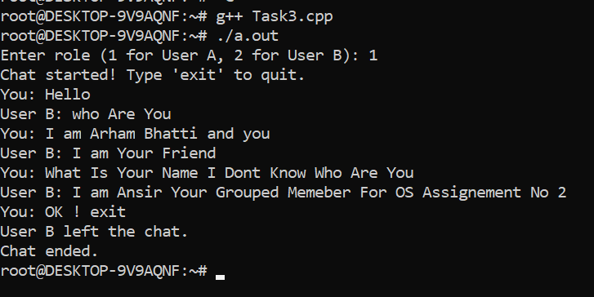
Terminal 2:
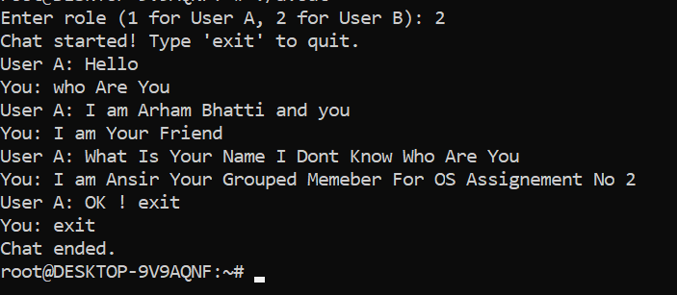
Task No 04
Question No 04:
Implement a concurrent file-processing system:
• Parent reads a line from a file
• Sends the line to a Child via a Pipe
• Child converts the line to uppercase and writes it to FIFO pipe
• Parent reads the result from FIFO and prints it on display
Solution:
#include <iostream>
#include <unistd.h>
#include <fcntl.h>
#include <sys/stat.h>
#include<sys/wait.h>
#include <string.h>
#include <stdlib.h>
using namespace std;
int main()
{
int pipe1[2];
char buffer[256];
char result[256];
const char *fifo="fifopipe";
if (pipe(pipe1)==-1)
{
cout<<"Pipe Creation Error!"<<endl;
return -1;
}
pid_t pid=fork();

mkfifo(fifo,04666);
if (pid<0)
{
cout<<"Fork Creation Failed"<<endl;
return 1;
}

if (pid>0)
{

close(pipe1[0]);
int fdr=open("task3.txt",O_RDONLY);
if (fdr==0)
{
cout<<"File Error"<<endl;
return -1;
}

int bytes;
int fdrfifo=open(fifo,0466);

if (fdrfifo==0)
{
cout<<"FIFO Path Error"<<endl;
return 1;
}

while ((bytes=read(fdr,buffer,sizeof(buffer)))>0)
{
write(pipe1[1],buffer,sizeof(buffer));
cout<<"Parent Read A lines From File: "<<buffer<<endl;

read(fdrfifo,result,sizeof(result));
sleep(2);
cout<<"Parent Read The Result From FIFO Pipe: "<<result<<endl;
}
close(fdr);
close(pipe1[1]);
close(fdrfifo);

}else{
close(pipe1[1]);
int fdw=open(fifo,04666);
int bytes;
while ((bytes=read(pipe1[0],buffer,sizeof(buffer)))>0)
{
buffer[bytes]='\0';

for (int i = 0;buffer[i]; i++)
{
buffer[i]=toupper(buffer[i]);
}

write(fdw,buffer,strlen(buffer));
cout<<"Child Convert Uppercase And Send To Parent : "<<buffer<<endl;
}
close(pipe1[0]);
close(fdw);

}

return 0;
}

Output:
